IT446 DATA MINING & DATA WAREHOUSING 26.11.2016
Assignment #3

Due Date: Saturday 3rd Dec 11:59 PM

Total Marks: 4

Q1. Given a decision tree, you have the option of (a) converting the decision tree to rules and then pruning the resulting rules, or (b) pruning the decision tree and then converting the pruned tree to rules. What advantage does (a) have over (b)? (0.75 Mark)

Q2. See the following Figure and compute the true positive rate .TPR/ , false positive rate .FPR/, Precision and Accuracy. (2 Marks)

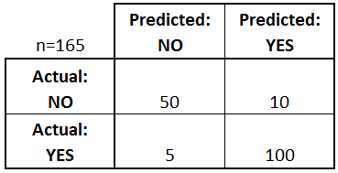

- There are two possible predicted classes: "yes" and "no". If we predict the presence of a disease, for example, "yes" would mean they have the disease, and "no" would mean they don't have the disease.
- The classifier made a total of 165 predictions (e.g., 165 patients were being tested for the presence of that disease).
- Out of those 165 cases, the classifier predicted "yes" 110 times, and "no" 55 times.
- In reality, 105 patients in the sample have the disease, and 60 patients do not.

Q3. Compare the advantages and disadvantages of eager classification (e.g., decision tree, Bayesian, neural network) versus lazy classification (e.g., k-nearest neighbor, case-based reasoning). ( 1 Mark)

Q4. The following decision tree has been created to predict what someone can do.
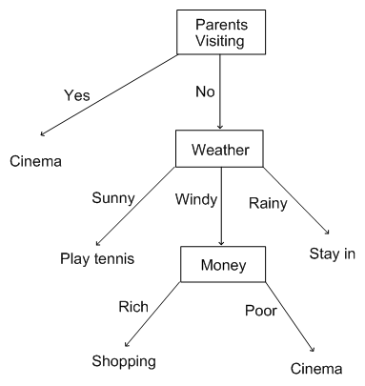

- Convert this tree to if then rules (0.25 Mark)
- Using the following testing data:
- Predict the class of each record (0.25 Mark)
 | Parents Visiting | Weather | Money | class | Prediction
1 | Yes | Sunny | Rich | Shopping
2 | Yes | Windy | Poor | Cinema
3 | No | Windy | Poor | Play tennis
4 | No | Rainy | Rich | Stay in
5 | Yes | Rainy | Poor | Stay in
6 | No | Windy | Rich | Cinema

- Calculate the accuracy of this model. (0.25 Mark)
- Interpret the obtained result (0.25 Mark)
- How we can improve the performance of the obtained model? (0.25Mark)

